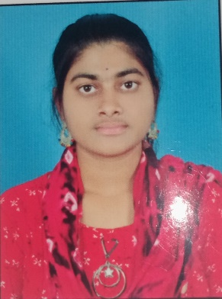 

Name: DIVYA SRI MACHA

Email:divyasrimacha2003@gmail.com

Ph no:9182325393

Gollagudem(V),Bayyaram(M).

**Career Objective**

Secure a responsible career opportunity to fully utilize my training and skills, while making a significant contribution to the success of the company and work in a dynamic professional environment with a growing organization as well as to enhance my knowledge new trends in the IT sector.

**Academic Qualifications**

* 2021-2025 : Bachelor of Technology in Electronics and Communication Engineering in Balaji Institution of Technology and Science. CGPA-8.64
* 2019-2021 : Intermediate in Auronodaya Junior College. Marks- 962\1000
* 2018-2019 :VB techno school. CGPA-9.5

**InternshiP**

May-June 2024 : PROGRAMMING WITH PYTHON

**TECHNICAL SKILLS**

* Basic knowledge : Basic concepts of C,Python,MySQL.
* Intermediate knowledge : Basic programming with JAVA

**CERTIFICATIONS** :

* Infosys springboard – Beginning of python and Java fundamentals.
* Cisco ideathon - Enterprise Networking, Security and Automation and Introduction to Networks.
* Maven silicon – vlsi design.

**PERSONAL DETAILS**:

* Name : Divyasri macha
* Fathers name : Veeranna
* DOB : 30/11/2003
* Gender : female
* Languages : English, Telugu.
* Nationality : Indian

**DECLARATION**:

* I Here by Declare That all Statements Made Above are True to the Best of my Knowledge And Belief.

SIGNATURE:DIVYA SRI.



